### Grove - Infrared Emitter

窗体顶端

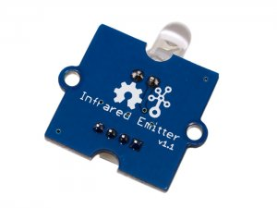

http://www.seeedstudio.com/depot/includes/templates/pure_green/images/next_l.gif

* [http://www.seeedstudio.com/depot/bmz_cache/4/42bb3b80c93727d54a9c3f303f1aed6b.image.55x41.jpg](http://www.seeedstudio.com/depot/images/product/infraredemitter.jpg)
* [http://www.seeedstudio.com/depot/bmz_cache/d/dabc13f3970b4d82b71133cdc4084eb8.image.55x41.jpg](http://www.seeedstudio.com/depot/images/product/infraredemitter_01.jpg)

http://www.seeedstudio.com/depot/includes/templates/pure_green/images/next_r.gif

* **Price:**

$4.35  [(Price Feedback)](javascript:void())

* **SKU:**

WLS12148P

* **Weight:**

5Gram

* **Units in Stock**

25

* **Designed by:**

[Seeed Studio](http://www.seeedstudio.com/)



[Other products from designer](http://www.seeedstudio.com/depot/seeed-studio-m-23.html)

* **Quantity:** Max: 25  
  
* [Add to Wish List](http://www.seeedstudio.com/depot/index.php?main_page=un_wishlist&products_id=993&cPath=139_204&action=un_add_wishlist)

### Description

The Infrared Emitter is used to transmit infrared signals through an infrared LED, while there is an Infrared receiver to get the signals on the other side . An infrared LED is like any other LED, with its color centered around 940nm. We can use the emitter not only to transmit data or commands, but also to emulate remotes to control your home appliance using an Arduino. The Infrared Emitter can transmit signals reliable up to 10 meters. Beyond 10 meters, the receiver may not get the signals.

Documents

Please visit our [wiki page](http://www.seeedstudio.com/wiki/Grove_-_Infrared_Emitter) for more info about this product. It will be appreciated if  you can help us improve the documents, add more demo code or tutorials. For technical support, please post your questions to our [forum](http://forum.seeedstudio.com/).

窗体底端